PYTHON-3
1. Python Strings

Strings in python are surrounded by either single quotation marks, or double quotation marks.
'hello' is the same as "hello".
- You can display a string literal with the print() function:
- String can assign a multiline string to a variable by using three quotes:
- Assigning a string to a variable is done with the variable name followed by an equal sign and the string:
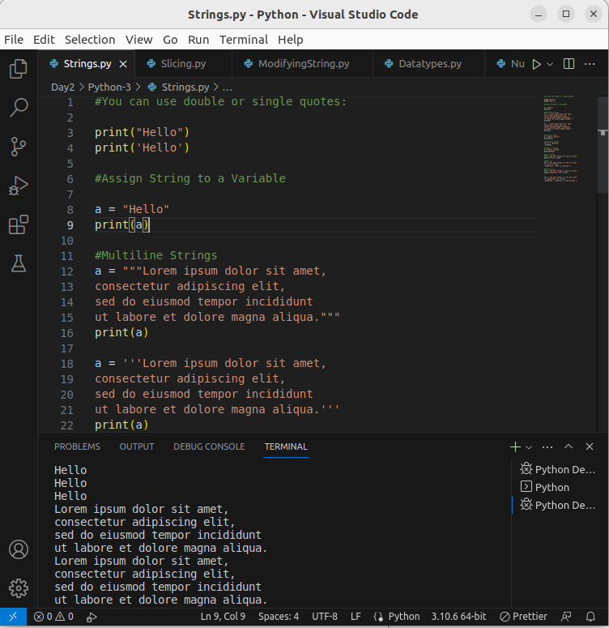
.
- Since strings are arrays, we can loop through the characters in a string, with a for loop.
- To get the length of a string, use the len() function
- To check if a certain phrase or character is present in a string, we can use the keyword in.
- To check if a certain phrase or character is NOT present in a string, we can use the keyword not in.
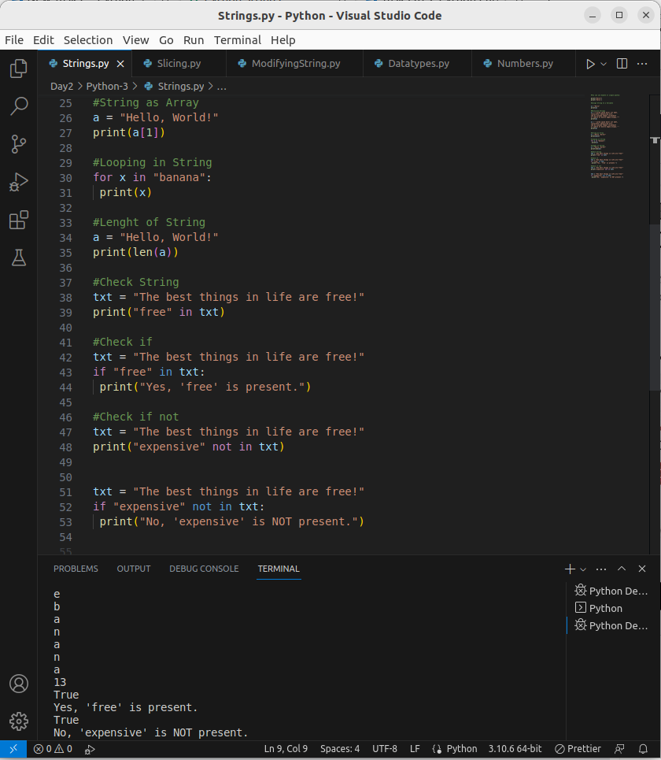
.
2.Python - Slicing Strings
- a range of characters can be retby using the slice syntax.
- By leaving out the start index, the range will start at the first character:
- By leaving out the end index, the range will go to the end:
- Use negative indexes to start the slice from the end of the string:
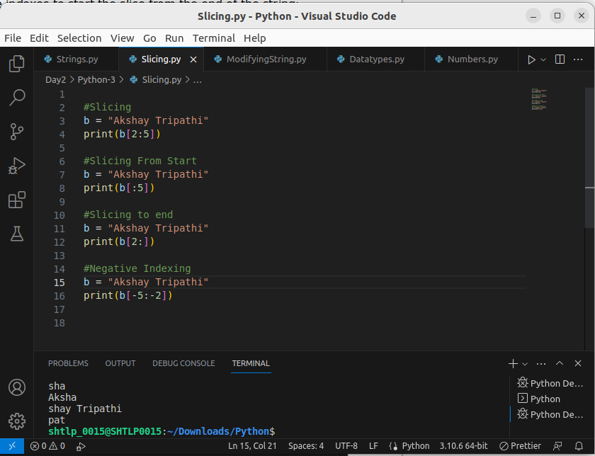
3. Python-Modifying String
- The upper() method returns the string in upper case:
- The lower() method returns the string in lower case:
- The strip() method removes any whitespace from the beginning or the end:
- The replace() method replaces a string with another string:
- The split() method returns a list where the text between the specified separator becomes the list items.
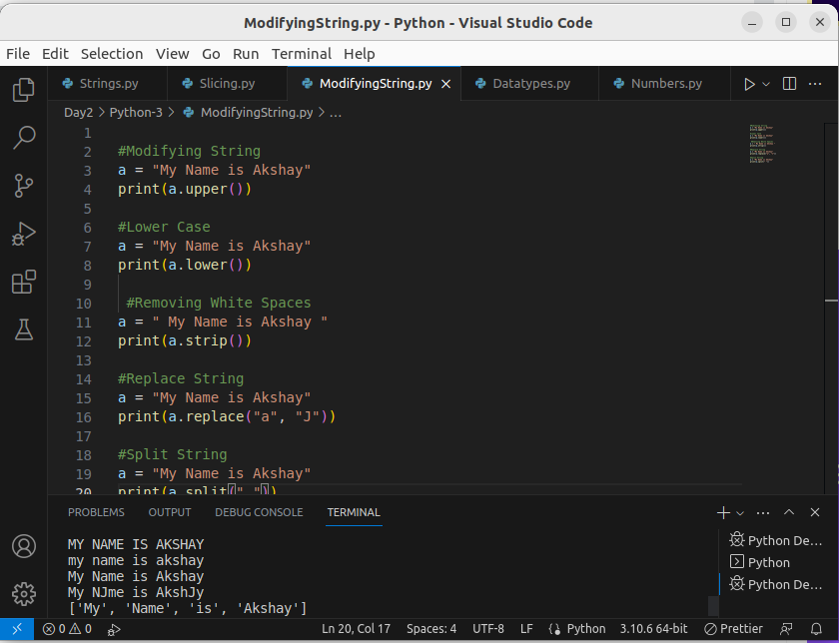
.
4.String Concatenation
- To concatenate, or combine, two strings you can use the + operator.
- To add a space between them, add a " ":
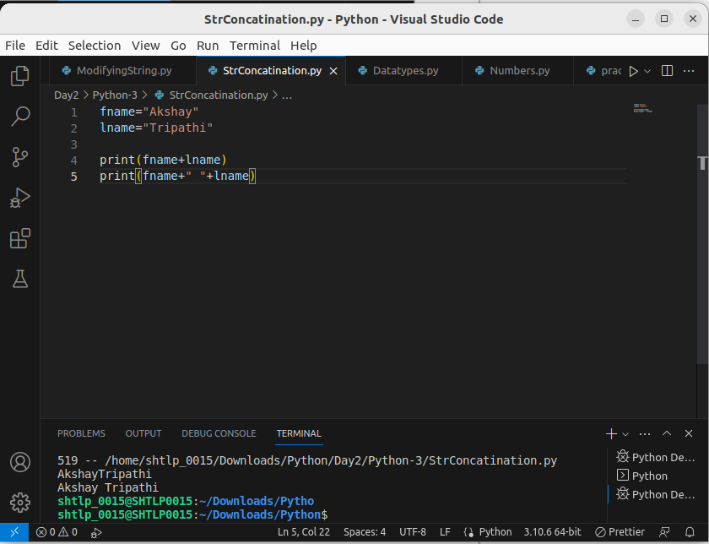
‘

5.String Formatting
- we cannot combine strings and numbers using +
- The format() method takes the passed arguments, formats them, and places them in the string where the placeholders {} are:
str=’ dkm kmcck {2} fkmc {1} kmfc {0}’
print(str.format(<int >,<int >,<int >))
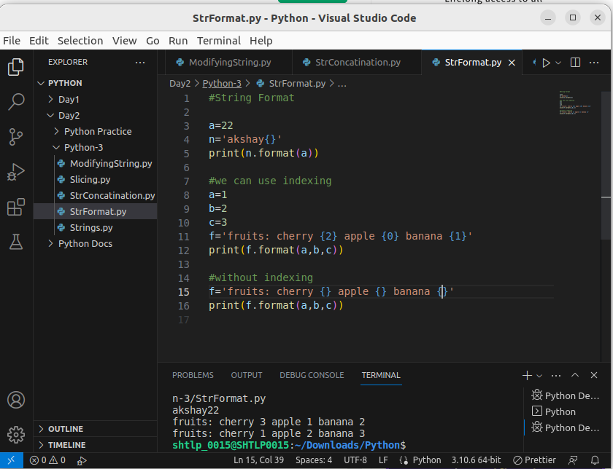
.

6.Escape Character:
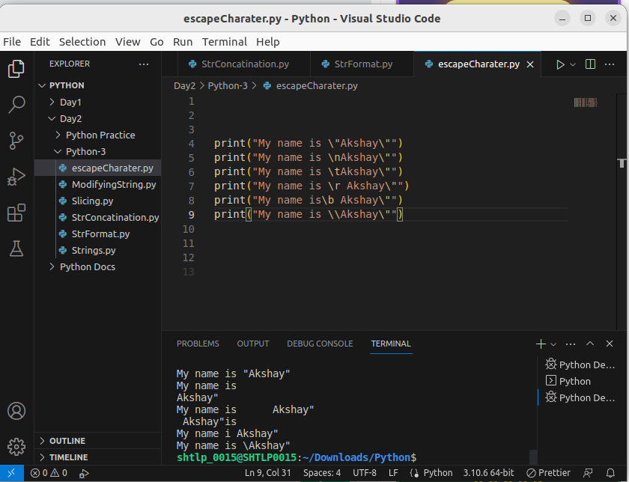
.
7. String are immutable
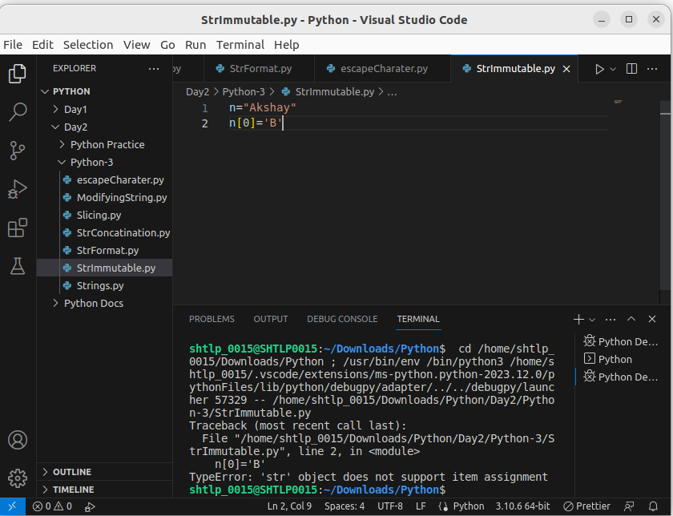
.
Solution:
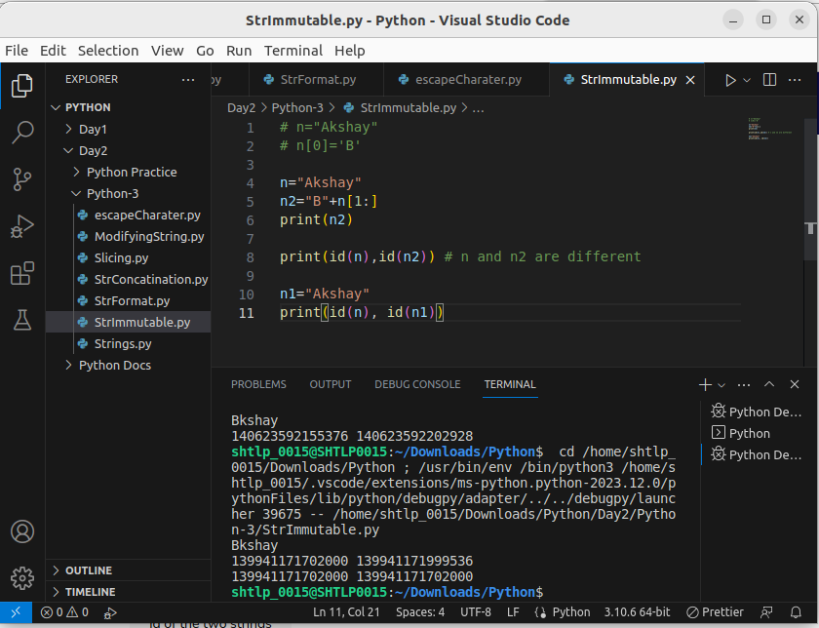
.

2. Booleans
- When you compare two values, the expression is evaluated and Python returns the Boolean answer:
- The bool() function allows you to evaluate any value, and give you True or False in return,
- Any string is True, except empty strings.
- Any number is True, except 0.
- Any list, tuple, set, and dictionary are True, except empty ones.
- False :(), [], {}, "", the number 0,
- Python also has many built-in functions that return a boolean value, like the isinstance() function, which can be used to determine if an object is of a certain data type:
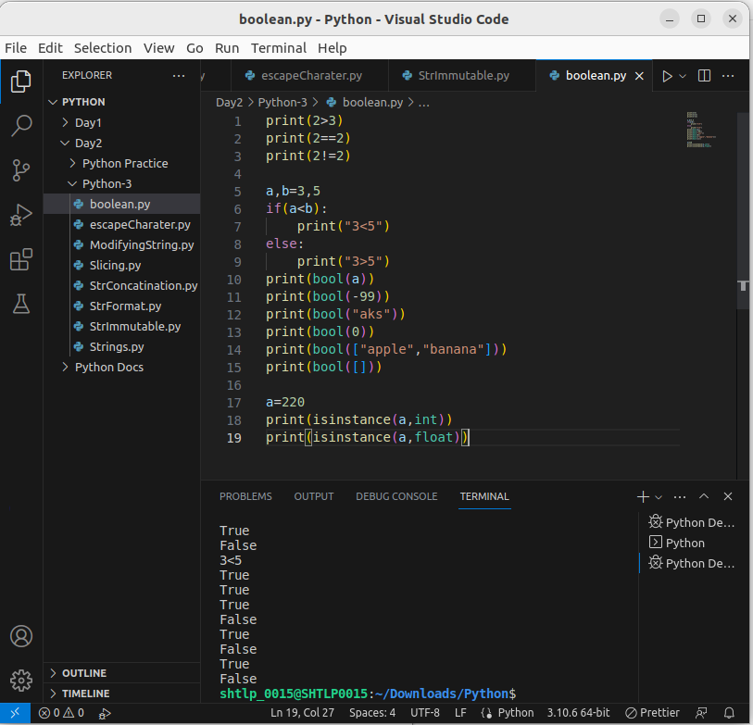
.

3. List
- Lists are used to store multiple items in a single variable.
- Lists are one of 4 built-in data types in Python used to store collections of data, the other 3 are tuple, set, and Dictionary

1.List Items
- List items are ordered, changeable, and allow duplicate values.
- List items are indexed, the first item has index [0], the second item has index [1] etc
- The list is changeable, meaning that we can change, add, and remove items in a list after it has been created.
- Allows duplicate items
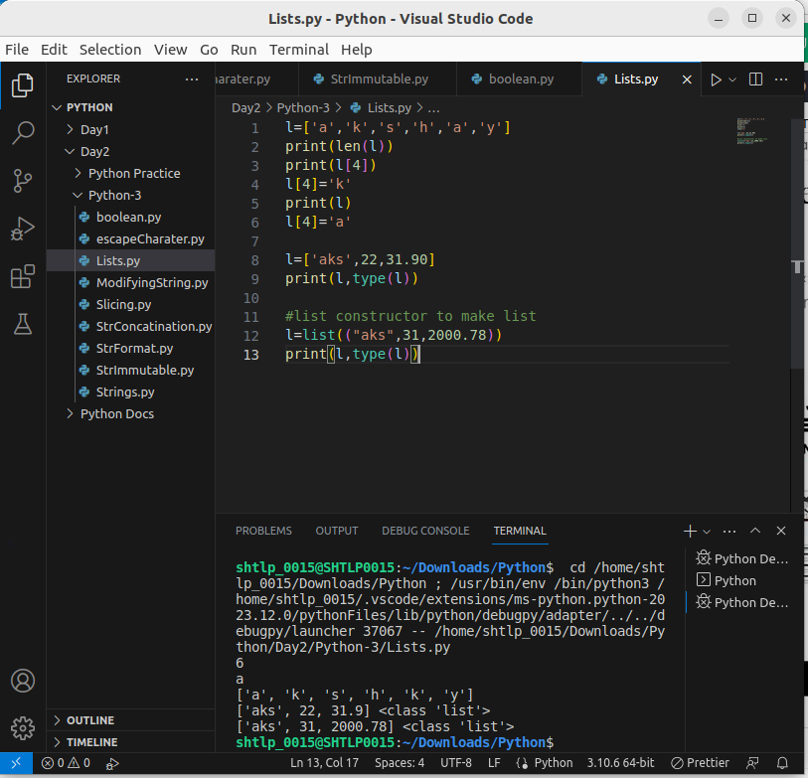
2. Accessing List Items
- The first item has index 0.
- Negative indexing means start from the end(-1 : last item, -2 : second last item etc).
- For l[x:y] The search will start at index x(included) and end at index y(not included).
- By leaving out the start value, the range will start at the first item:
- By leaving out the end value, the range will go on to the end of the list:
- negative indexes if you want to start the search from the end of the list [-4:-1}
- To determine if a specified item is present in a list use the in keyword:
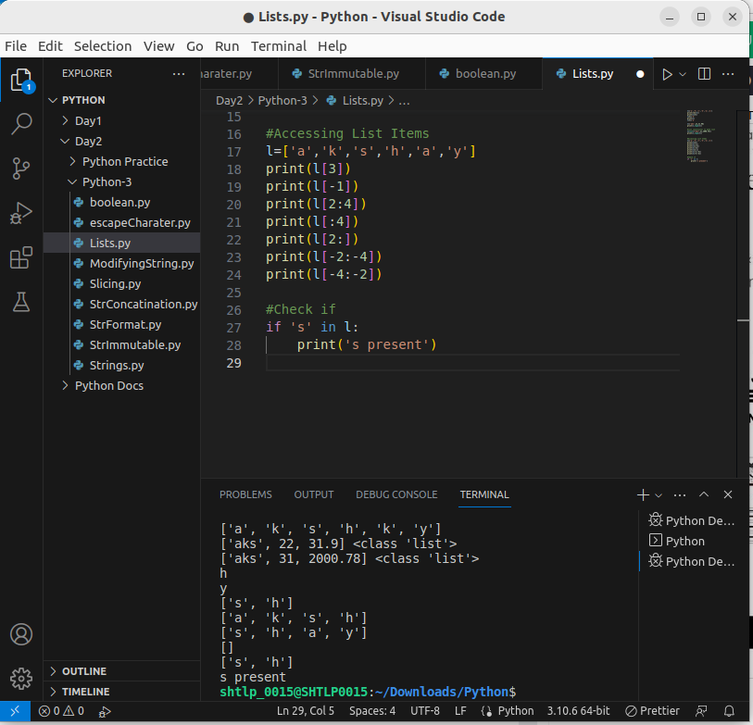
.

3. Changing List Items
- To change the value of a specific item, refer to the index number
- To change the value of items within a specific range, define a list with the new values, and refer to the range of index numbers where you want to insert the new values
- If you insert more items than you replace, the new items will be inserted where you specified, and the remaining items will move accordingly
- If you insert less items than you replace, the new items will be inserted where you specified, and the remaining items will move accordingly
- The insert() method inserts an item at the specified index
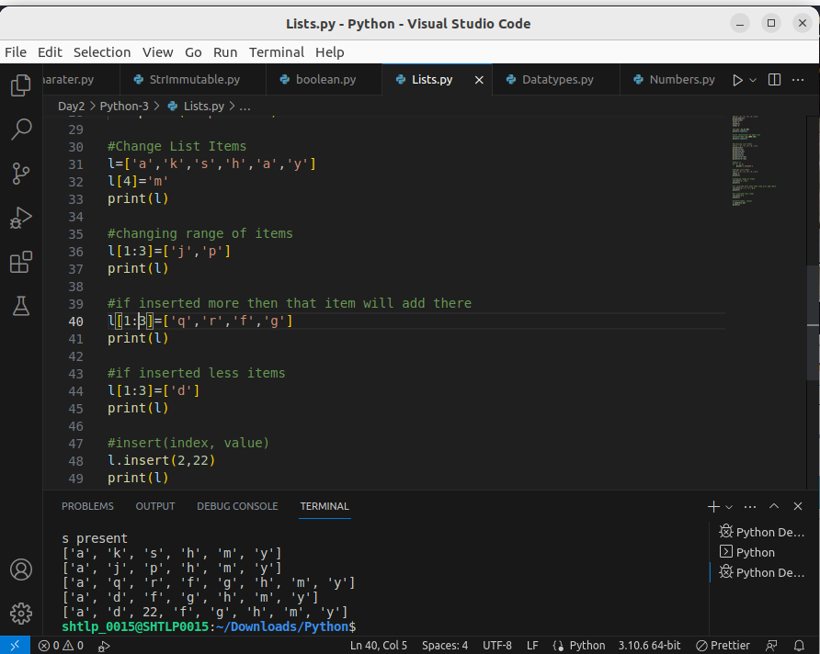
.

4. List Add Items
- To add an item to the end of the list, use the append() method:
- The insert() method inserts an item at the specified index
- To append elements from another list to the current list, use the extend() method.
- The extend() method does not have to append lists, you can add any iterable object (tuples, sets, dictionaries etc.).
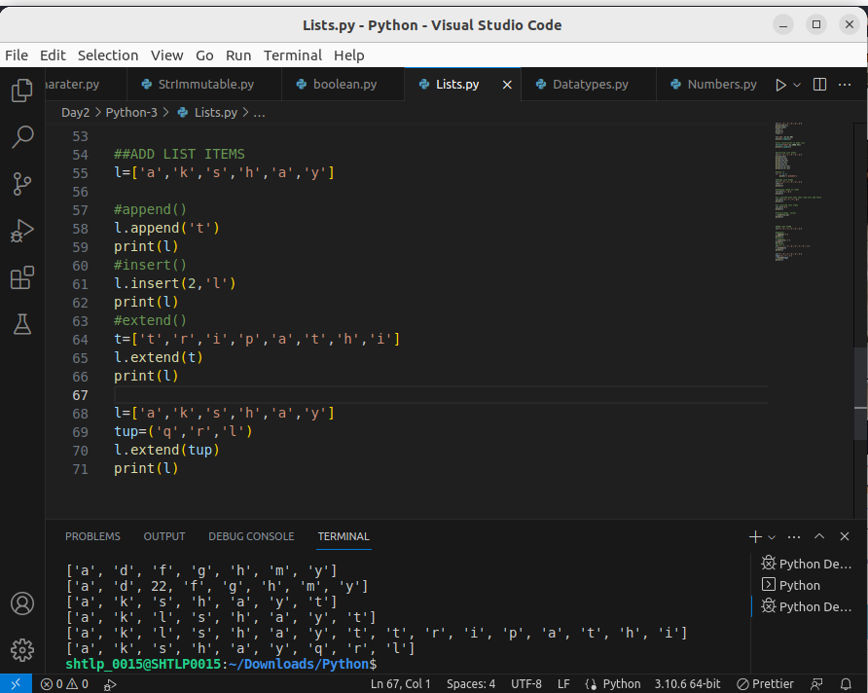
.
6. Remove List Item
- The remove() method removes the specified item.
- The pop() method removes the specified index.
- If you do not specify the index, the pop() method removes the last item.
- The del keyword also removes the specified index:
- The del keyword can also delete the list completely.
- The clear() method empties the list.The list still remains, but it has no content.

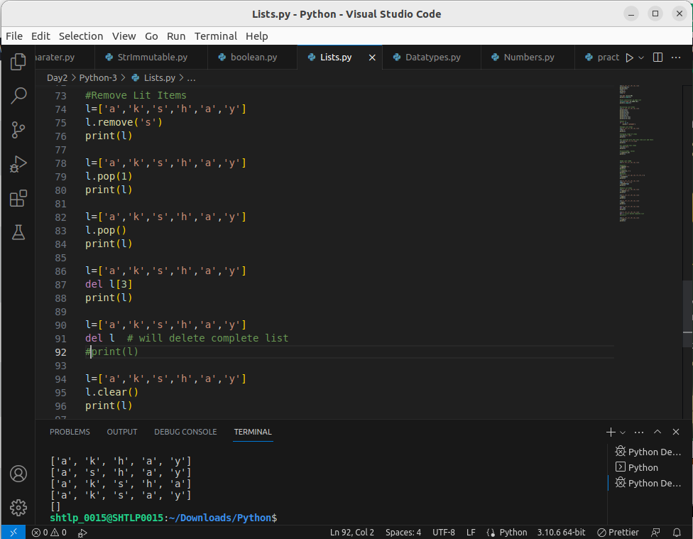
.
7.Loop List
- loop through the list items by using a for loop:
- Use the range() and len() functions to create a suitable iterable
- loop through the list items by using a while loop. Use the len() function to determine the length of the list, then start at 0 and loop your way through the list items by referring to their indexes. Remember to increase the index by 1 after each iteration

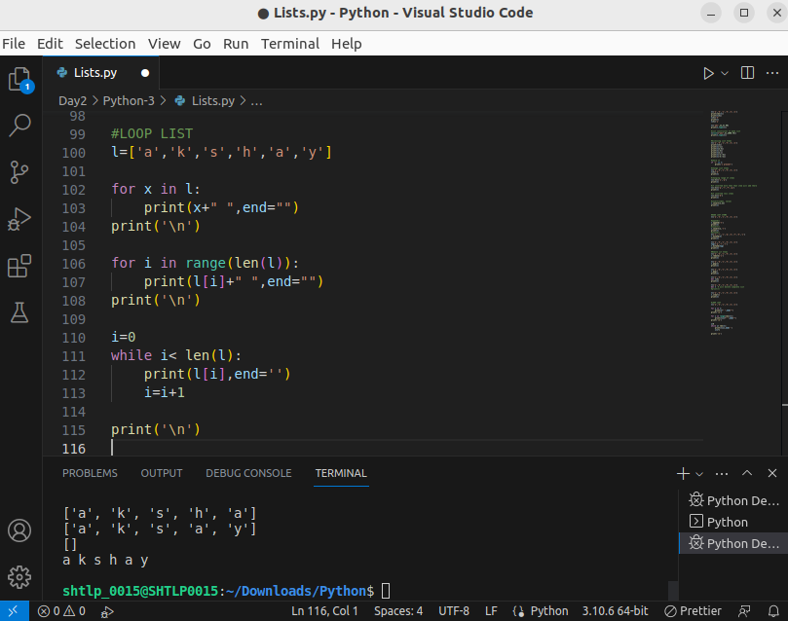
.
8.Sorting List
- List objects have a sort() method that will sort the list alphanumerically, ascending, by default
- Sort the list of both type alphabeticallly and numerically
- To sort descending, use the keyword argument reverse = True
- You can also customize your own function by using the keyword argument key = function. The function will return a number that will be used to sort the list (the lowest number first)
- By default the sort() method is case sensitive, resulting in all capital letters being sorted before lower case letters
- By default the sort() method is case sensitive, resulting in all capital letters being sorted before lower case letters:
- case-insensitive sort function, use str.lower as a key function
- to reverse the order of a list, regardless of the alphabet The reverse() method reverses the current sorting order of the elements

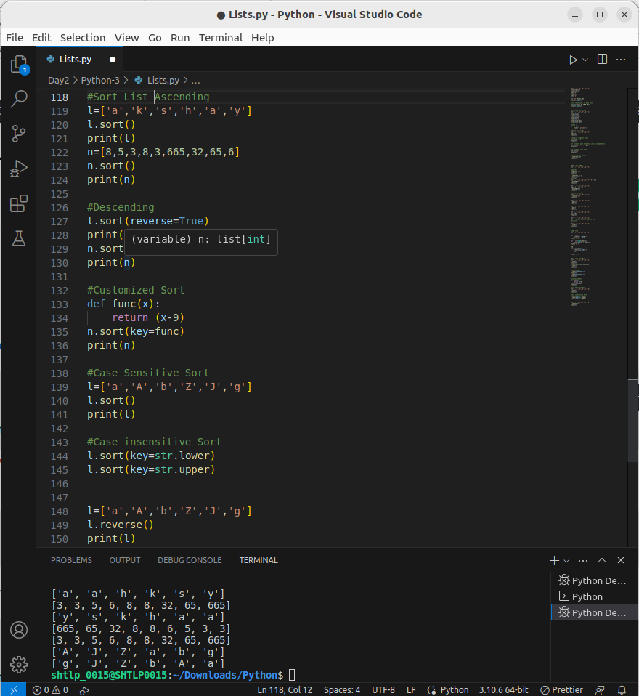
.

9.Copy a List
- You cannot copy a list simply by typing list2 = list1, because: list2 will only be a reference to list1, and changes made in list1 will automatically also be made in list2.
- There are ways to make a copy, one way is to use the built-in List method copy().
- Another way to make a copy is to use the built-in method list().
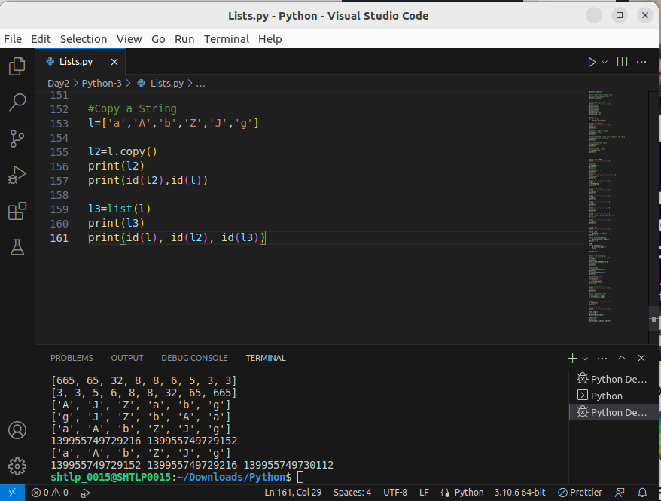
.
10.Join two List
- One of the easiest ways are by using the + operator.
- Another way to join two lists is by appending all the items from list2 into list1, one by one
- Or you can use the extend() method, where the purpose is to add elements from one list to another list:

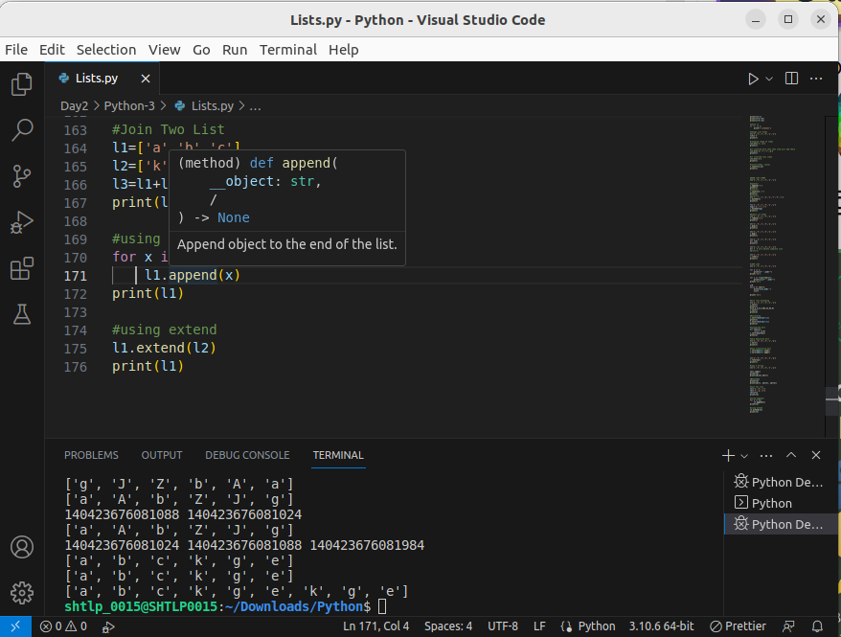
.

11. count()
